Catalog Migration Instructions for

IM9733397 & IM9922607

Author: Supriya/Raghav

Creation Date: June 15 , 2017

Last Updated: June 15 , 2017

Version: 1

1. **Title, Subject, Last Updated Date, Reference Number**, **and** **Version** are marked by a Word Bookmark so that they can be easily reproduced in the header and footer of documents. When you change any of these values, be careful not to accidentally delete the bookmark. **You can make bookmarks visible by selecting the Office Button>Word Options>Advanced> and checking the Show bookmarks option in the Show document content region.**

**Approvals:**

|  |  |
| --- | --- |
| Approver 1 | Vinay Pachika |
| Approver 2 | Viswam Nair |

1. To add additional approval lines, press [Tab] from the last cell in the table above.
2. You can delete any elements of this cover page that you do not need for your document.

# Document Control

## Change Record

3

| Date | Author | Version | Change Reference |
| --- | --- | --- | --- |
| June 15 , 2017 | Supriya/Raghav | 1.0 |  |

## Reviewers

| Name | Position |
| --- | --- |
| Abhishek Chattopadhyay | Accenture |
|  |  |
|  |  |

Contents

1 Document Control ii

1.1 Change Record ii

1.2 Reviewers ii

2 Installation Instructions for BI System Setups Migration 4

2.1 Pre-Migration Steps 4

Migration Steps 5

2.1.1 Catalog Migration 5

2.1.1.1 Component: OOB Fixed Assets 5

3 Open and Closed Issues 8

3.1 Open Issues 8

3.2 Closed Issues 8

1. To update the table of contents, put the cursor anywhere in the table and press [F9]. To change the number of levels displayed, select the menu option Insert‑>Index and Tables, make sure the Table of Contents tab is active, and change the Number of Levels to a new value.

# Installation Instructions for BI System Setups Migration

|  |  |
| --- | --- |
| **Source Environment Name: TEST** | **Machine:** TCGIT3 |

|  |  |
| --- | --- |
| **Target Environment Name**: UAT | **Machine:** TCGI13 |

## Pre-Migration Steps

1. The following Migration documents needs to be completed before deploying the Catalog Objects in the Target Environment.
   1. RPD Migration Document
2. Take a backup of the entire catalog from the Shared Folder level

## Migration Steps

### Catalog Migration

* Log into the OBIEE Answers
* https://TargetServer.oracleoutsourcing.com/analytics/
* Go to Catalog

#### Component: Cigna Fixed Assets

|  |  |  |  |  |  |  |  |  |  |
| --- | --- | --- | --- | --- | --- | --- | --- | --- | --- |
| **S.No** | **Dev SVN #** | **TS SVN #** | **CRP SVN #** | **UAT SVN #** | **PROD SVN #** | **File Name** | **File Type** | **File Location in SVN** | **Unarchive Catalog Location in Target OBIEE Instance** |
| **1** |  |  |  |  |  | **Cigna Finance-Shared** | **Folder** | **ORACLE_BI_REPO/Accenture-DEV/Catalog/relase 3A/ Cigna Finance-Shared /Post Allocated expenses Dashboard/Detail** | **/Shared Folders/Cigna Finance-Shared** |
| **2** |  |  |  |  |  | **Cigna Finance-Shared** | **Folder** | **ORACLE_BI_REPO/Accenture-DEV/Catalog/relase 3A/ Cigna Finance-Shared /Post Allocated expenses Dashboard/Summary** | **/Shared Folders/Cigna Finance-Shared** |
| **3** |  |  |  |  |  | **Cigna Custom Financials** | **Folder** | **ORACLE_BI_REPO/Accenture-DEV/Catalog/relase 3A/ Cigna Custom Financials /Cigna Fixed aseet dashboard** | **/Shared Folders/Cigna Custom Financials** |

1. Go to Folder ‘Shared Folder

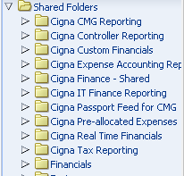

1. Unarchive the files at the mentioned location as per migration Table above.
2. During Unarchiving select the following options.
   * + - 1. Select **All** for ‘Replace’ from the Drop Down
         2. Select **Inherit** for ‘ACL’ from the Drop Down.
         3. Click OK
3. Open the catalog and cross verify the presence of the new catalog object( Asset Details ) under Shared Folder > Cigna Finace-Shared

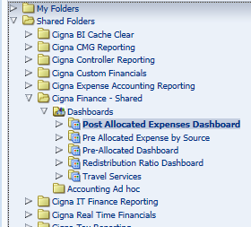

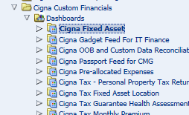

1. Verify that the deployment has been completed successfully by following these steps
   * + - 1. Open **Dashboards** and select the dashboard from the dropdown list.

**Cigna Finace-Shared**

Run the dashboard and there should be no ODBC error.

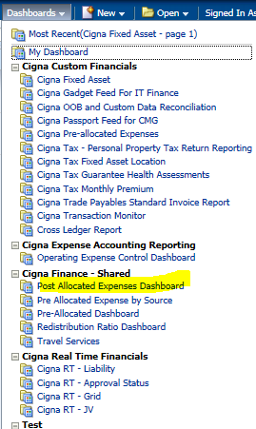

.

* + - * 1. Open **Dashboards** and select the dashboard from the dropdown list.

**Cigna Custom Financials**

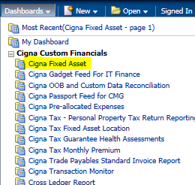

1. Include a subset of test steps that will confirm that the customization has been installed properly.

# Open and Closed Issues

1. Add open issues that you identify while writing or reviewing this document to the open issues section. As you resolve issues, move them to the closed issues section and keep the issue ID the same. Include an explanation of the resolution.  
     
   When this work product is complete, any open issues should be transferred to the project- or process-level Issue Log (Manage focus area) and managed using a project level Issue Form (Manage focus area). In addition, the open items should remain in the open issues section of this work product, but flagged in the resolution column as being transferred.

## Open Issues

| ID | Issue | Resolution | Responsibility | Target Date | Impact Date |
| --- | --- | --- | --- | --- | --- |
|  |  |  |  |  |  |
|  |  |  |  |  |  |
|  |  |  |  |  |  |
|  |  |  |  |  |  |

## Closed Issues

| ID | Issue | Resolution | Responsibility | Target Date | Impact Date |
| --- | --- | --- | --- | --- | --- |
|  |  |  |  |  |  |
|  |  |  |  |  |  |
|  |  |  |  |  |  |
|  |  |  |  |  |  |

---------------------------------------------End Of Document-----------------------------------------